LAB4: FPGA-based Mental Binary Math Game

Yuan Tian

1675170

ECE6370

**Project Overview**:

The goal of the Lab is to design a mental binary math game that can be played by one player on the DE2-115 FPGA board. Accessing the game module will require the player to set up a countdown timer. Afterwards, the player will press a button to generate a random 4-bit number and the number will be displayed on one of the 7-segment display devices. The player can observe the number on the display and input another 4-bit binary number from second set of toggle switches in the same way. And the second number will be displayed on one of the 7-segment display devices. The sum of two number will also be displayed on third 7-segment display device. If the sum of two binary number equals to 15(hexadecimal ‘f’), the player successfully scores 1 point and one of the green LED on board will lighten up, otherwise the player scores no point and one of red LED will lighten up. The game play will be over after countdown timer rans out.

The top-level system architecture named “Lab3_TIAN_Y” consists of 17 sub-modules: 6 of “decoder_4to7” modules, 2 of “ButtonShaper” modules, 2 of ‘loadreg’ modules, 1 of ‘AccessCtrl’ module, 1 of “adder” module, 1 of “RNG” module, 1 of “cdmod” module, 2 of “OneSecTimer” modules and 1 of “f_veri_mod” module. The overall system description figure is shown below.

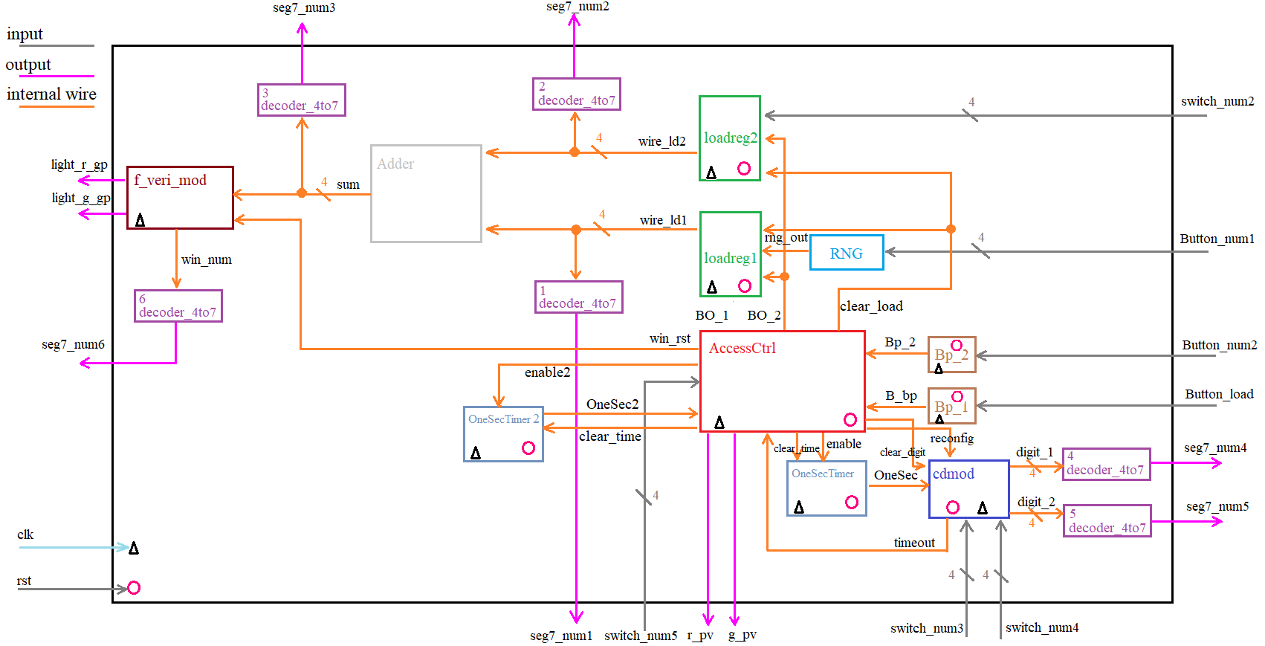

Figure 1. Top-level system architecture

**Sub-module Description**:

1. “decoder_4to7” (1)

Input signal: “wire_ld1”

Output signal: “seg7_num1”

Functionality: this module converts the 4-bit input signal from the random number generator to 7-bit output signal that can be used to drive the 7-segment display device.

1. “decoder_4to7” (2)

Input signal: “wire_ld2”

Output signal: “seg7_num2”

Functionality: this module converts the 4-bit input signal from the toggle switch of the player to 7-bit output signal that can be used to drive the 7-segment display device.

1. “decoder_4to7” (3)

Input signal: “sum”

Output signal: “seg7_sum”

Functionality: this module converts the 4-bit input signal from “adder” module to 7-bit output signal that can be used to drive the 7-segment display device.

1. “decoder_4to7” (4)

Input signal: “digit_1”

Output signal: “seg7_num4”

Functionality: this module converts the first digit number (base 10) from the countdown timer to 7-bit output signal that can be used to drive the 7-segment display device.

1. “decoder_4to7” (5)

Input signal: “digit_1”

Output signal: “seg7_num5”

Functionality: this module converts the second digit number (base 10) from the countdown timer to 7-bit output signal that can be used to drive the 7-segment display device.

1. “decoder_4to7” (6)

Input signal: “win_num”

Output signal: “seg7_num6”

Functionality: this module converts the 4-digit binary score points number to 7-bit output signal that can be used to drive the 7-segment display device.

1. “adder”

Input signal: “wire_ld1”, “wire_ld2”

Output signal: “sum”

Functionality: this module takes in two 4-bit binary numbers from the random number generator and the player, adds up the number and passes the result to next modules.

1. “f_veri_mod”

Input signal: “sum”, “rst”, “clk”

Output signal: “light_r”, “light_g”, “win_num”

Functionality: this module takes in binary sum from “adder” module, compares the result to binary number “1111” (15 in decimal) and toggles the output signal for red and green LEDs depending on whether they are equal, outputs a 4-bit number tracking the scores of the player.

1. “Bp1”

Input signal: “Button_num1”, “rst”, “clk’.

Output signal: “B_bp”

Functionality: this module takes in the physical button signal from multifunction button and convert it to a single cycle pulse.

1. “Bp2”

Input signal: “Button_num2”, “rst”, “clk’

Output signal: “Bp_2”

Functionality: this module takes in the physical button signal from the player and convert it to a single cycle pulse.

1. “loadreg1”

Input signal: “rng_out”, “rst”, “clk’, “clear_load”, “BO_1”

Output signal: “wire_ld1”

Functionality: this module takes in the 4-bit number from random number generator, if password authentication is successful and button is pressed, the 4-bit number will be loaded into next module. If “clear” is “1”, reset the output to ‘0’

1. “loadreg2”

Input signal: “BO_2”, “rst”, “clk’, “clear_load”, “switch_num2”

Output signal: “wire_ld2”

Functionality: this module takes in the 4-bit number from the player, if password authentication is successful and button is pressed, the 4-bit number will be loaded into next module. If “clear” is “1”, reset the output to ‘0’

1. “AccessCtrl”

Input signal: “Bp_2”, “rst”, “clk’, “B_bp”, “timeout”, “switch_num5”

Output signal: “wire_rst”, “BO_1”, “BO_2”, “enable”, “reconfig”, “clear_load”, “clear_time”, “clear_digit”, “r_pv”, “g_pv”

Functionality: this module controls the flow of the entire game, which includes password verification, countdown timer reconfiguration and game play procedures.

1. “OneSecTimer”

Input signal: “enable”, “rst”, “clk”, “clear_time”

Output signal: “OneSec”

Functionality: this module generates one-second pulses after enabled.

1. “OneSecTimer2”

Input signal: “enable2”, “rst”, “clk”, “clear_time”

Output signal: “OneSec”

Functionality: this module generates one-second pulses for timing the “Pause”, “Resume”, “Replay” and “Log out” functions.

1. “cdmod”

Input signal: “OneSec”, “rst”, “clk”, “switch_num3”, “switch_num4”, “clear_digit”.

Output signal: “timeout”, “digit_1”, “digit_2”

Functionality: this module is used to set up the countdown time by taking in the inputs of two sets of switches. Whenever receives the pulse of “OneSec”, this module will count down once and update the digit number that is used for the 7-segment display device. When it rans out the time, the module will send a notice signal to the “AccessCtrl” module.

1. “RNG”

Input signal: “Button_num1”, “rst”, “clk”

Output signal: “rng_out”

Functionality: this module generates a random number by sampling the pulses whire the button is pressed.

**FPGA Board Testing Results**:

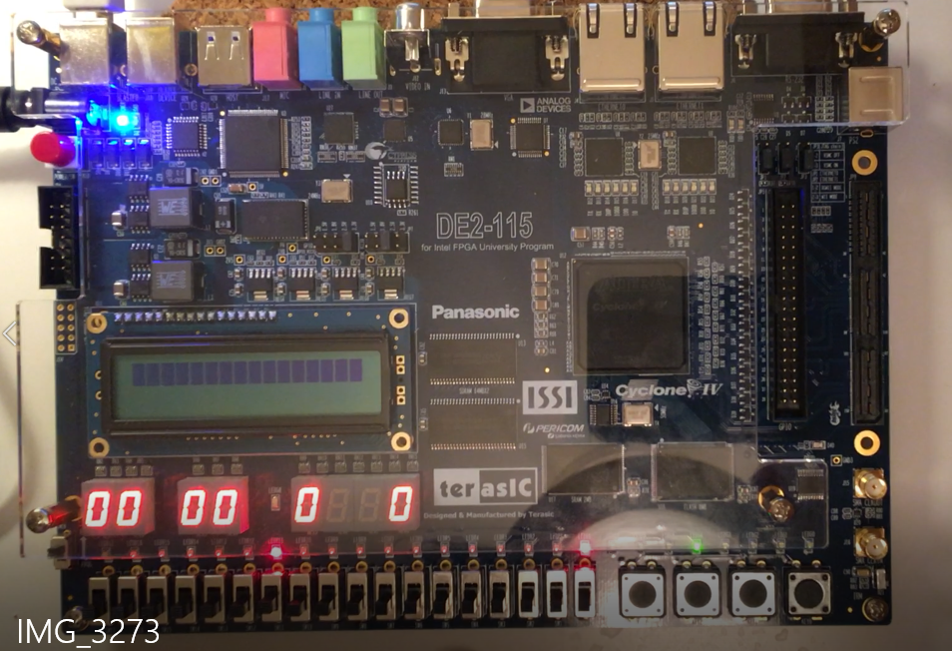

Figure 2. Initial State

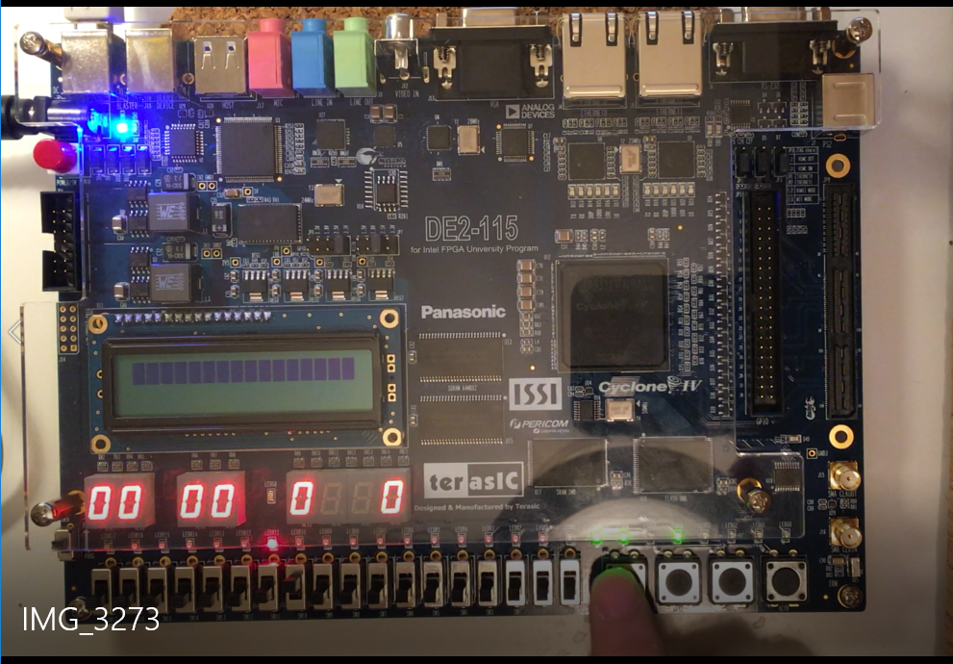

Figure 3. Receive Correct Password

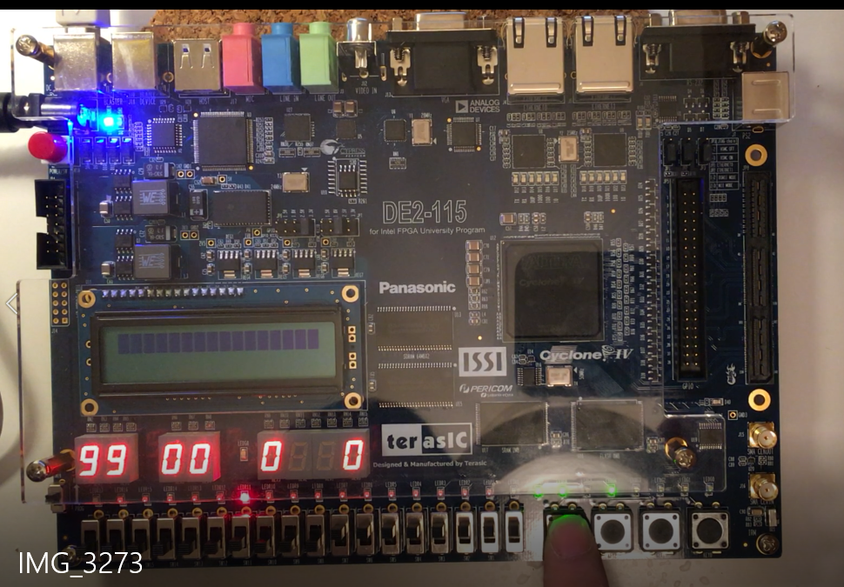

Figure 4. Time Loading

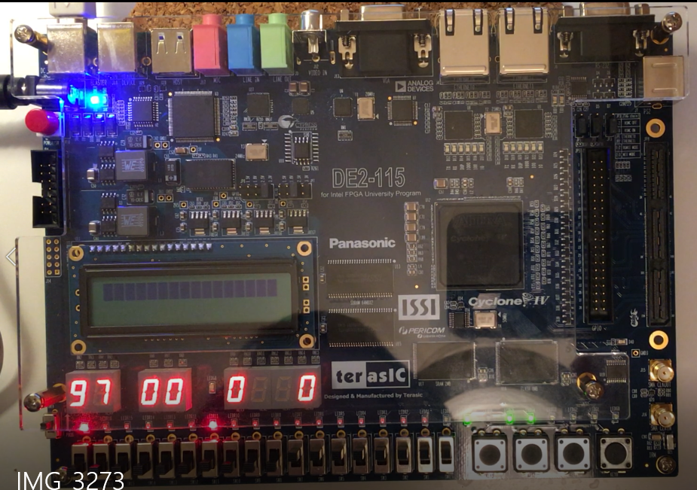

Figure 5. Game Start

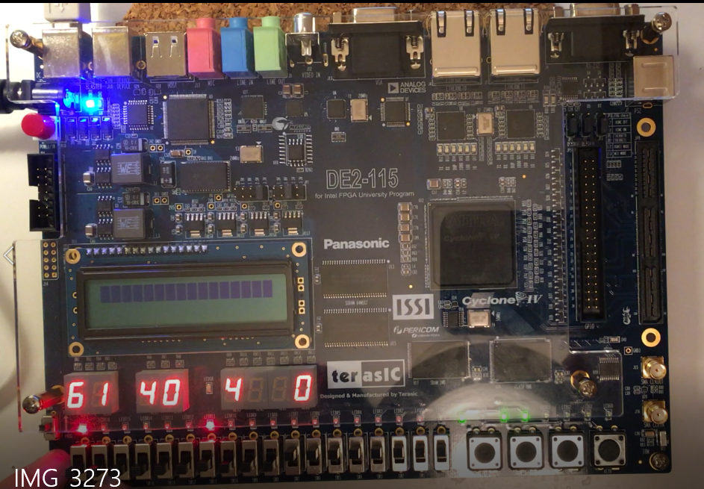

Figure 6. RNG Load

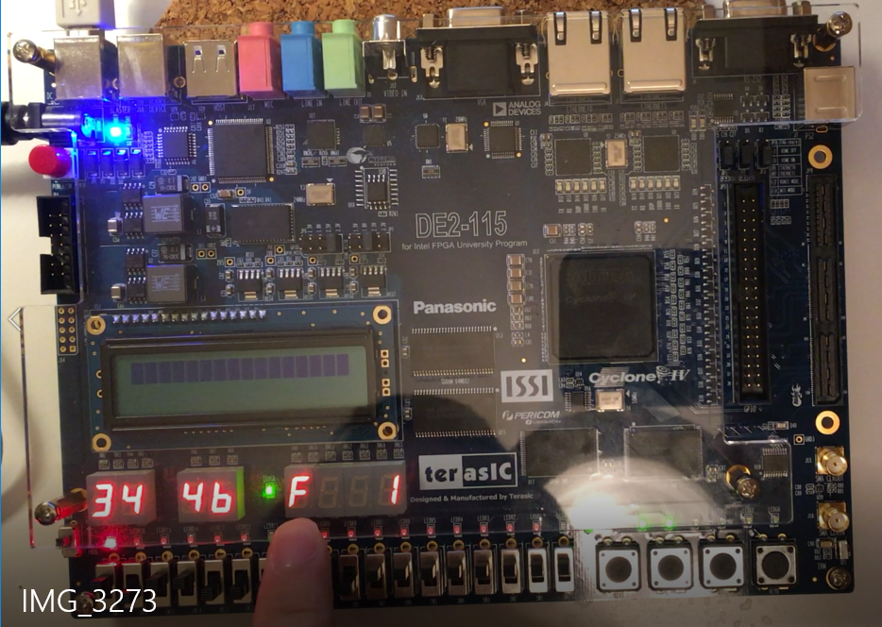

Figure 7. Player Input Load

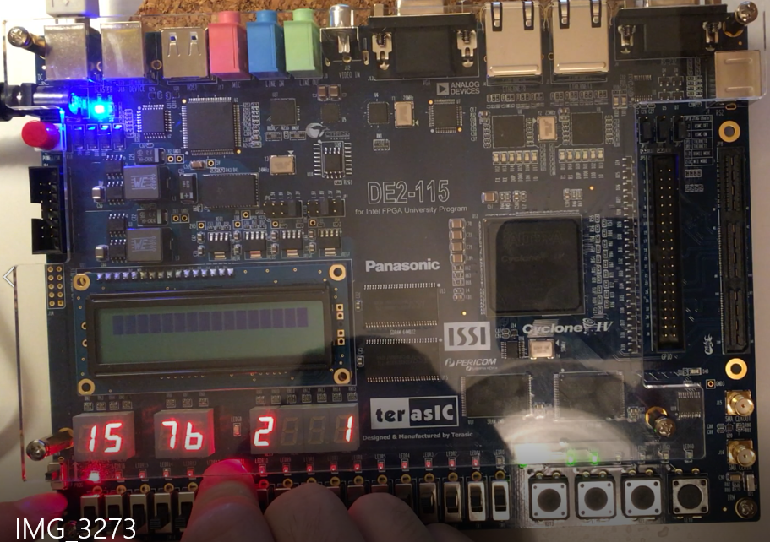

Figure 8. New RNG Load

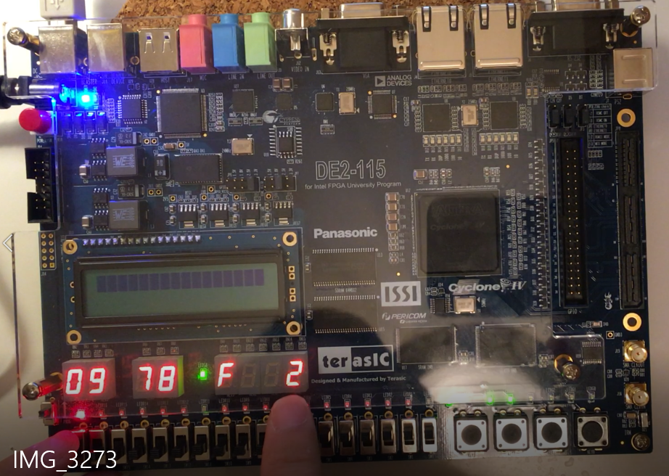

Figure 9. New Player Input Load (2nd success)

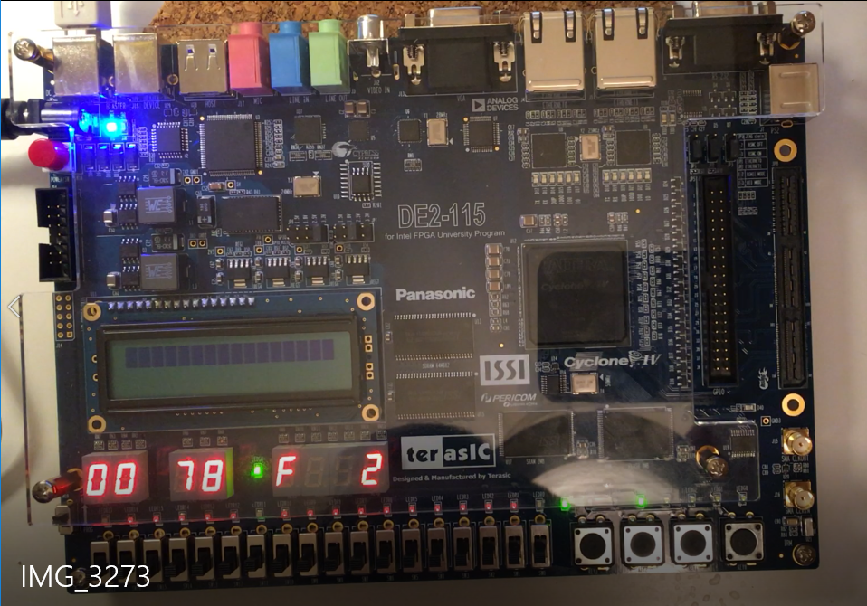

Figure 10. Timeout

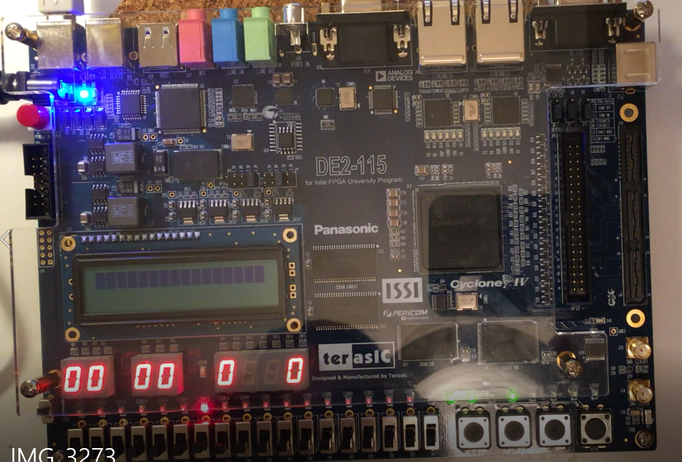

Figure 11. Replay the Game (clear score)

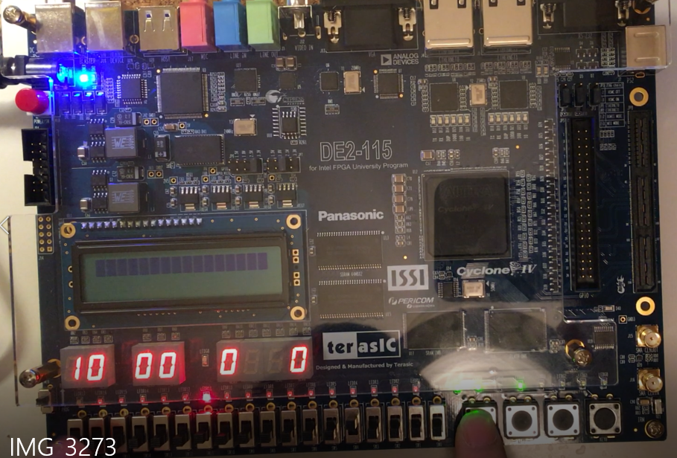

Figure 11. Reload New Time

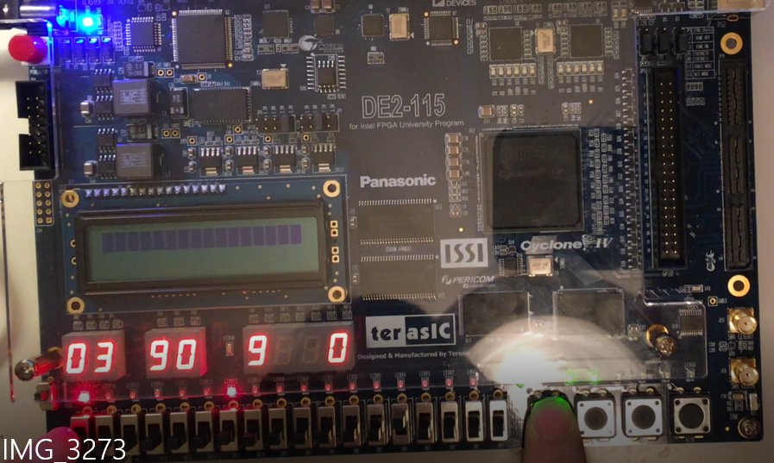

Figure 12. Reload the New RNG

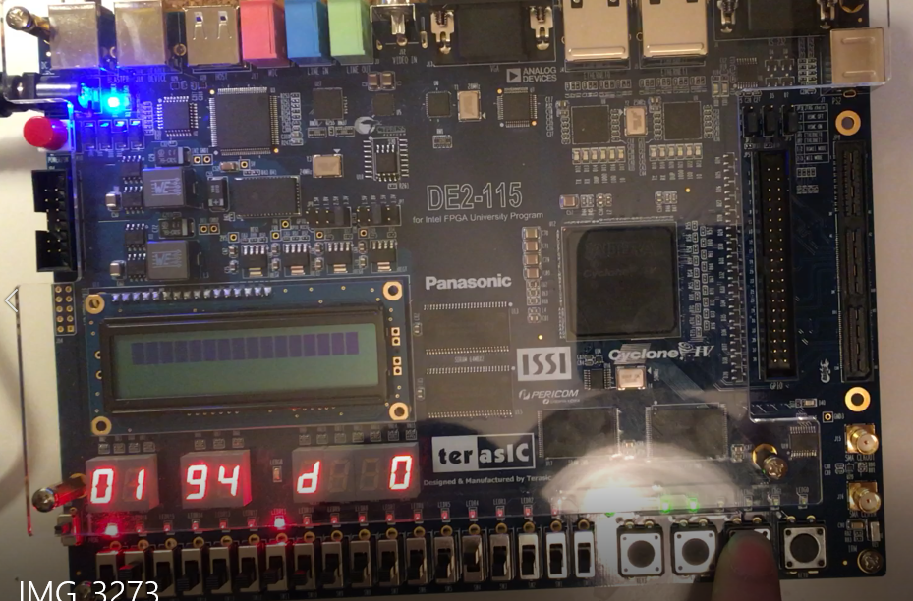

Figure 13. Reload the New User Input

**New Feature Added (since Lab3):**

1. Pause:

When game mode is in “gameplay” mode (Countdown timer hasn’t received to 0), the player can pause the game by pressing the password load button for once. If the game is paused, the timer will stop counting down and all displays will freeze for further action.

1. Resume:

If the game mode is in “pause” mode, by pressing the load button for once, the game will resume to play. The count down timer will starts count down from where it stopped and the displays will response to the player’s input again.

1. Game Over:

If the player wants to terminate the current game and restart from the beginning of the game, he or she can press the load button twice within 1 second. All the current game data and displays will be cleared, and the player can restart the game by resetting the countdown timer.

1. Log out

If the player wants to log out current game play, he or she can press the load button three times within 2 seconds. After log out, all the current game play data and displays will be cleared, and the player have to log in with his or her password to access the game again.

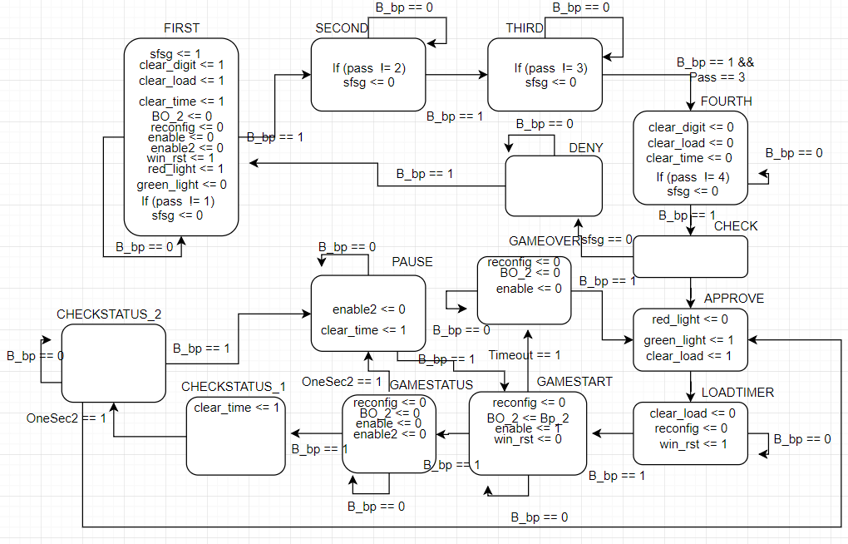

Figure 14. AccessController State-machine

In order to add new features above, the major changes are focused on the design of the “AccessController” module (refer to figure 14). Three new states were added to accommodate the new features. The empty state “CheckStatus_1” was added for creating a buffer state for making sure the variables are updated when needed. Two new variables, “clear_digit” and “clear_time”, were added for clear the game play data and displays when entering new states of features. The demonstration of fully working features will be in the Demo video.

**Test Conclusion**:

The major difference of my module design is that my coding design for “Accesscontroller” allows the time input being shown on display. After the player pressed the button, the time shown on display will be loaded to the system. The other feature of my code is that there is a load button for random number generator, so the random number is visible only after pressing the load button. Other than the two major user interface difference, the module design performs well and fulfill all functional requirements.

The sub-modules all perform according to the requirements. The “OneSec” timer can generate pulse for each second. The core module, “cdtimer”, performs without any glitches and errors. And the module also supports “Pause”, “Resume”, “GameOver” and “Logout” features.

The only limitation is that the bonus function, “score” function, is implemented using a 4-bit number which only tracks 15 points.

In conclusion, this module design is fully working.

**Appendix**

**Coding:**

ECE6370

//Lab4

//Author: Yuan Tian (1675170)

//random number generator

//this module uses button and counter to generate a random 4-bit number

module rng (Button, rst, clk, num_out);

input Button, rst, clk;

output[3:0] num_out;

assign B_inverted = ~ Button;

counter counter_1(B_inverted, rst, clk, num_out);

endmodule

//Lab4

//Author: YUAN TIAN(5170)

//This module is designed to be a button

//shaper for the physical button existing on

//the FPGA Board. This module helps to generate

//single pulse when physical button is pushed

module ButtonShaper (b_in, clk, rst, b_out);

input b_in, clk, rst;

output b_out;

reg b_out;

parameter INIT=0, PULSE = 1, WAIT = 2;

reg [1:0] state, nextstate;

always @(state, b_in)

begin

case(state)

INIT:

begin

b_out <= 1'b0;

if(b_in == 1'b1)

begin

nextstate <= INIT;

end

else

begin

nextstate <= PULSE;

end

end

PULSE:

begin

b_out <= 1'b1;

nextstate <= WAIT;

end

WAIT:

begin

b_out <= 1'b0;

if(b_in == 1'b1)

begin

nextstate <= INIT;

end

else

begin

nextstate <= WAIT;

end

end

default:

begin

b_out <= 1'b0;

nextstate <= INIT;

end

endcase

end

always @(posedge clk)

begin

if(rst == 0)

begin

state <= INIT;

end

else

begin

state <= nextstate;

end

end

endmodule

//ECE6370

//LAB 4

//Author: Yuan Tian (1675170)

//4 bit adder

//This module is design for performing the

//addition operation of two 4-bit binary number

module adder (in1, in2, sum1);

input [3:0] in1,in2;

output [3:0] sum1;

reg [3:0] sum1;

always @(in1, in2)

begin

sum1= in1 + in2;

end

endmodule

module cdtimer(rst, clear_digit, clk, decrement_in, No_borrow_in, reconfig, num_in, decrement_out, num_out, No_borrow_out);

input rst, clk, decrement_in, reconfig, No_borrow_in, clear_digit;

input [3:0]num_in;

output decrement_out, No_borrow_out;

output [3:0]num_out;

reg decrement_out, No_borrow_out;

reg [3:0]num_out;

always@(posedge clk) begin

if (rst == 0) begin

num_out <= 0;

decrement_out <= 0;

No_borrow_out <= 0;

end

else if (clear_digit == 1) begin

num_out <= 0;

decrement_out <= 0;

No_borrow_out <= 0;

end

else begin

No_borrow_out <= 0;

if(reconfig == 1) begin

if(num_in > 9)begin

num_out <= 9;

end

else if(num_in == 0)begin

num_out <= num_in;

end

else begin

num_out <= num_in;

end

end

else begin

if(decrement_in == 1) begin

if(num_out != 0) begin

num_out <= num_out - 1;

end

else begin

if(No_borrow_in == 0) begin

num_out <= 9;

decrement_out <= 1;

end

else begin

decrement_out <= 0;

No_borrow_out <= 1;

end

end

end

else begin

if(num_out == 0 && No_borrow_in == 1)begin

No_borrow_out <= 1;

end

num_out <= num_out;

decrement_out <= 0;

end

end

end

end

endmodule

//ECE6370

//LAB 4

//Author: Yuan Tian (1675170)

//4 bit to 7 bit decoder

//This module is design for the 7-segment display module on

//FPGA DE2-115 Board. This decoder module can convert a

//4-bit number into a 7-bit number that can be used to

//drive the 7-segment display module, where a "0" indicates

//lightening up the specific bar and "1" indicates turning

//off the bar.

module decoder_4to7 (decoder_in, decoder_out);

input [3:0] decoder_in;

output[6:0] decoder_out;

reg [6:0] decoder_out;

always @ (decoder_in)

begin

case (decoder_in)

4'b0000:

begin

decoder_out = 7'b1000000; //0

end

4'b0001:

begin

decoder_out = 7'b1111001; //1

end

4'b0010:

begin

decoder_out = 7'b0100100; //2

end

4'b0011:

begin

decoder_out = 7'b0110000; //3

end

4'b0100:

begin

decoder_out = 7'b0011001; //4

end

4'b0101:

begin

decoder_out = 7'b0010010; //5

end

4'b0110:

begin

decoder_out = 7'b0000010; //6

end

4'b0111:

begin

decoder_out = 7'b1111000; //7

end

4'b1000:

begin

decoder_out = 7'b0000000; //8

end

4'b1001:

begin

decoder_out = 7'b0010000; //9

end

4'b1010:

begin

decoder_out = 7'b0001000; //10(a)

end

4'b1011:

begin

decoder_out = 7'b0000011; //11(b)

end

4'b1100:

begin

decoder_out = 7'b0100111; //12(c)

end

4'b1101:

begin

decoder_out = 7'b0100001; //13(d)

end

4'b1110:

begin

decoder_out = 7'b0000110; //14(e)

end

4'b1111:

begin

decoder_out = 7'b0001110; //15(f)

end

default:

begin

decoder_out = 7'b0111111; //default(-)

end

endcase

end

endmodule

module OneSecTimer(rst, clear_time, clk, enable, OneSec);

input enable, rst, clk, clear_time;

output OneSec;

wire msTimer_out, CountTo100_out;

Timer1ms timer1(enable, clear_time, rst, clk, msTimer_out);

CountTo100 timer2(rst, clear_time, clk, msTimer_out, CountTo100_out);

CountTo10 timer3(rst, clear_time, clk, CountTo100_out, OneSec);

Endmodule

// Lab 4

// Author: Yuan Tian

// load register HW4

module LoadReg ( clk, rst, load, clear, in4bit, out4bit );

input clk, rst, load;

input [3:0] in4bit;

output [3:0] out4bit;

input clear;

reg [3:0] out4bit;

always @ (posedge clk)

begin

if ( rst == 1)begin

if ( load == 1)

begin

out4bit <= in4bit;

end

else begin

if(clear == 1) begin

out4bit <= 4'b0000;

end

end

end

else if (rst == 0)

begin

out4bit <= 4'b0000;

end

end

endmodule

//Lab 4

//Author: YUAN TIAN (5170)

//This module is designed to authorize game play

//This module verify the passward input by user

//and grant the access if the passward is correct

module AccessCtrl(Pass, B_bp, Bp_2, clk, rst, timeout, OneSec2, BO_2, reconfig, enable, enable2, win_rst, clear_load, clear_digit, clear_time, red_light, green_light, LED_1, LED_2, LED_3);

input B_bp, Bp_2, clk, rst, timeout, OneSec2;

input [3:0] Pass;

output red_light, green_light, BO_2, enable, enable2, reconfig, win_rst, clear_load, clear_digit, clear_time, LED_1, LED_2, LED_3;

reg red_light, green_light, BO_2, enable, enable2, reconfig, win_rst,clear_load, clear_digit, clear_time, LED_1, LED_2, LED_3;

reg sfsg;

reg [3:0] state;

parameter First = 4'b0000, Second = 4'b0001;

parameter Third = 4'b0010, Fourth = 4'b0011;

parameter Check = 4'b0100, Approve = 4'b0101;

parameter Deny = 4'b0110, LoadTimer = 4'b0111;

parameter GameStart = 4'b1000, GameOver = 4'b1001;

parameter GameStatus = 4'b1010, CheckStatus_1 = 4'b1011;

parameter Pause = 4'b1100, CheckStatus_2 = 4'b1101;

always @(posedge clk)

begin

if(rst == 0)

begin

state <=First;

end

else

begin

case(state)

First:

begin

sfsg <= 1;

clear_digit <= 1;

clear_load <= 1;

clear_time <= 1;

BO_2 <= 0;

reconfig <= 0;

enable <= 0;

enable2 <= 0;

win_rst <= 1;

red_light <= 1;

green_light <= 0;

if (B_bp == 0)

begin

state <= First;

end

else

begin

if(Pass == 1)

begin

//doing nothing

end

else

begin

sfsg <= 0;

end

state <= Second;

end

end

Second:

begin

if (B_bp == 0)

begin

state <= Second;

end

else

begin

if(Pass == 2)

begin

//doing nothing

end

else

begin

sfsg <= 0;

end

state <= Third;

end

end

Third:

begin

clear_digit <= 0;

clear_load <= 0;

clear_time <= 0;

if (B_bp == 0)

begin

state <= Third;

end

else

begin

if(Pass == 3)

begin

//doing nothing

end

else

begin

sfsg <= 0;

end

state <= Fourth;

end

end

Fourth:

begin

if (B_bp == 0)

begin

state <= Fourth;

end

else

begin

if(Pass == 4)

begin

//doing nothing

end

else

begin

sfsg <= 0;

end

state <= Check;

end

end

Check:

begin

if (sfsg == 1)

begin

state <= Approve;

end

else

begin

state <= Deny;

end

end

Deny:

begin

if (B_bp == 0)

begin

state <= Deny;

end

else

begin

state <= First;

end

end

Approve:

begin

red_light <= 1'b0;

green_light <= 1'b1;

state <= LoadTimer;

end

LoadTimer:

begin

clear_load <= 0;

reconfig <= 1;

win_rst <= 1;

LED_1<= 1;

if (B_bp == 1)

begin

state <= GameStart;

end

else

begin

state <= LoadTimer;

end

end

GameStart:

begin

reconfig <= 0;

LED_2 <= 1;

LED_1 <= 0;

BO_2 <= Bp_2;

enable <= 1;

win_rst <= 0;

if(B_bp == 1)

begin

BO_2 <= 0;

enable <= 0;

state <= GameStatus;

end

else if(timeout == 1)

begin

state <= GameOver;

end

else

begin

state <= GameStart;

end

end

GameStatus:

begin

reconfig <= 0;

BO_2 <= 0;

enable <= 0;

enable2 <= 1;

if(OneSec2 == 1)

begin

state <= Pause;

end

else if(B_bp == 1)

begin

state <= CheckStatus_1;

clear_time <= 1;

end

else

begin

state <= GameStatus;

end

end

CheckStatus_1:

begin

/*enable2 <= 0;

if(PushCount == 3)

begin

state <= First;

PushCount <= 0;

end

else if(PushCount == 2)

begin

state <= Approve;

clear_load <= 1;

PushCount <= 0;

end

else

begin

state <= Pause;

PushCount <= 0;

end*/

state <= CheckStatus_2;

end

CheckStatus_2:

begin

if(OneSec2 == 1)

begin

state <= Approve;

clear_load <= 1;

end

else if(B_bp == 1)

begin

state <= First;

end

else

begin

state <= CheckStatus_2;

end

end

Pause:

begin

enable2 <= 0;

clear_time <= 1;

if(B_bp == 1)

begin

state <= GameStart;

end

else

begin

state <= Pause;

end

end

GameOver:

begin

reconfig <= 0;

LED_3 <= 1;

LED_2 <= 0;

BO_2 <= 0;

enable <= 0;

if(B_bp == 1)

begin

state <= Approve;

clear_load <= 1;

end

else

begin

state <= GameOver;

end

end

default:

begin

red_light <= 1'b1;

green_light <= 1'b0;

state <= First;

end

endcase

end

end

endmodule

module cdmod(rst, clear_digit, clk, switch_num3, switch_num4, reconfig, OneSec, timeout, num_out_1st, num_out_2nd);

input rst, clk, reconfig, OneSec, clear_digit;

input [3:0]switch_num3;

input [3:0]switch_num4;

output [3:0]num_out_1st;

output [3:0]num_out_2nd;

output timeout;

wire decrement, No_borrow;

wire port1, port2;

assign port1 = 1;

cdtimer FirstDigit(rst, clear_digit, clk, OneSec, No_borrow, reconfig, switch_num3, decrement, num_out_1st, timeout);

cdtimer SecondDigit(rst, clear_digit, clk, decrement, port1, reconfig, switch_num4, port2, num_out_2nd, No_borrow);

endmodule

//ECE6370

//Lab4

//Author: Yuan Tian (1675170)

//Button Counter

//After the user presses the button, the counter will increment by 1 for each posedge

module counter(B, rst, clk, count);

input B, rst, clk;

output[3:0] count;

reg[3:0] count;

always @(posedge clk)

begin

if (rst == 0)

begin

count <= 0;

end

else

begin

if (B == 1)

begin

if ((count == 16) | (count > 16))

begin

count <= 0;

end

else

begin

count <= count + 1;

end

end

else

begin

//doing nothing

end

end

end

endmodule

module Timer1ms(enable, clear_time, rst, clk, pulse);

input enable, clear_time, clk, rst;

output pulse;

reg [15:0] count;

reg pulse;

always@ (posedge clk)

if(rst == 0) begin

count <= 0;

pulse <= 0;

end

else if(clear_time == 1) begin

count <= 0;

pulse <= 0;

end

else begin

if (enable == 1) begin

if(count == 50000) begin

count <= 0;

pulse <= 1;

end

else begin

count <= count + 1;

pulse <= 0;

end

end

else begin

count <= 0;

pulse <= 0;

end

end

endmodule

//LAB 4

//Author: Yuan Tian (1675170)

//Hexdecimal_F_Verify

//This module is design for verify if the sum of two numbers input by

//two players add up to 15(hex f). If sum is 15, the green lED will

//light up, whose signal will be '1', otherwise the red LED light up

module f_veri_mod (

//input

sum_f,

clk,

clear,

rst,

//output

light_r,

light_g,

score);

input [3:0] sum_f;

input clk, clear, rst;

output light_r, light_g;

output reg [3:0] score;

reg light_r, light_g;

reg already_count;

always @(posedge clk) begin

if(rst == 0)

begin

light_r <= 1;

light_g <= 0;

score <= 0;

already_count <= 0;

end

else

begin

if(clear == 1)

begin

score <= 0;

already_count <= 0;

end

else

begin

if(sum_f == 4'b1111)

begin

light_r <= 0;

light_g <= 1;

if(already_count == 0)

begin

score <= score + 1;

already_count <= 1;

end

end

else

begin

light_r <= 1;

light_g <= 0;

already_count <= 0;

end

end

end

end

endmodule

module CountTo100( rst, clear_time, clk, pulse_in, pulse_out);

input pulse_in, clear_time, rst, clk;

output pulse_out;

reg [6:0] count;

reg pulse_out;

always@ (posedge clk)

if(rst == 0) begin

count <= 0;

pulse_out <= 0;

end

else if(clear_time == 1) begin

count <= 0;

pulse_out <= 0;

end

else begin

if(pulse_in == 1)begin

if(count == 100)begin

count <= 0;

pulse_out <= 1;

end

else begin

count <= count + 1;

pulse_out <= 0;

end

end

else begin

pulse_out <= 0;

end

end

endmodule

module CountTo10( rst, clear_time, clk, pulse_in, pulse_out);

input pulse_in, clear_time, rst,clk;

output pulse_out;

reg [3:0] count;

reg pulse_out;

always@ (posedge clk)

if(rst == 0) begin

count = 0;

pulse_out = 0;

end

else if(clear_time == 1) begin

count <= 0;

pulse_out <= 0;

end

else begin

if(pulse_in == 1)begin

if(count == 10)begin

count <= 0;

pulse_out <= 1;

end

else begin

count <= count + 1;

pulse_out <= 0;

end

end

else begin

pulse_out <= 0;

end

end

endmodule

module Lab3_TIAN_Y (

//inputs

switch_num2, switch_num3, switch_num4, switch_num5, button_num1, button_num2, button_load, button_rst, clk,

//outputs

seg7_num1, seg7_num2, seg7_num3, seg7_num4, seg7_num5, seg7_num6, light_r_gp, light_g_gp, r_pv, g_pv, LED_1, LED_2, LED_3, enable);

input [3:0] switch_num2, switch_num3, switch_num4, switch_num5;

input button_num1, button_num2, button_load, button_rst, clk;

output [6:0] seg7_num1, seg7_num2, seg7_num3, seg7_num4, seg7_num5, seg7_num6;

output light_r_gp, light_g_gp, r_pv, g_pv, LED_1, LED_2, LED_3, enable;

wire [3:0] wire_ld1, wire_ld2, sum, win_num, digit_1, digit_2, rng_out;

wire win_rst, BO_2, B_bp, Bp_2, enable, OneSec, timeout, enable2, OneSec2, reconfig, clear_load, clear_digit, clear_time;

wire port_OneSec;

assign port_OneSec = 0;

f_veri_mod f_veri_mod_1(sum, clk, win_rst, button_rst, light_r_gp, light_g_gp, win_num);

adder adder_1(wire_ld1, wire_ld2, sum);

LoadReg lr_1(clk, button_rst, BO_2, clear_load,rng_out, wire_ld1);

LoadReg lr_2(clk, button_rst, BO_2, clear_load,switch_num2, wire_ld2);

rng rng_1(button_num1, button_rst, clk, rng_out);

AccessCtrl AC1(switch_num5, B_bp, Bp_2, clk, button_rst, timeout, OneSec2, BO_2, reconfig, enable, enable2, win_rst, clear_load, clear_digit, clear_time, r_pv, g_pv, LED_1, LED_2, LED_3);

OneSecTimer OST_1(button_rst, port_OneSec, clk, enable, OneSec);

OneSecTimer OST_2(button_rst, clear_time, clk, enable2, OneSec2);

cdmod cdmod_1(button_rst, clear_digit, clk, switch_num3, switch_num4, reconfig, OneSec, timeout, digit_1, digit_2);

ButtonShaper B1(button_load, clk, button_rst, B_bp);

ButtonShaper B2(button_num2, clk, button_rst, Bp_2);

decoder_4to7 dcoder_1(wire_ld1, seg7_num1);

decoder_4to7 dcoder_2(wire_ld2, seg7_num2);

decoder_4to7 dcoder_3(sum, seg7_num3);

decoder_4to7_10 dcoder_4(digit_1, seg7_num4);

decoder_4to7_10 dcoder_5(digit_2, seg7_num5);

decoder_4to7 dcoder_6(win_num, seg7_num6);

endmodule